Project Design Phase-II
Technology Stack (Architecture & Stack)

Date | 26 February 2026
Team ID | LTVIP2026TMIDS40509
Project Name | Exploratory-Analysis-Of-RainFall-Data-In-India-For-Agriculture
Maximum Marks | 4 Marks

Technical Architecture:
The Deliverable shall include the architectural diagram as below and the information as per the table1 & table 2
Example: Order processing during pandemics for offline mode
Reference: https://developer.ibm.com/patterns/ai-powered-backend-system-for-order-processing-during-pandemics/
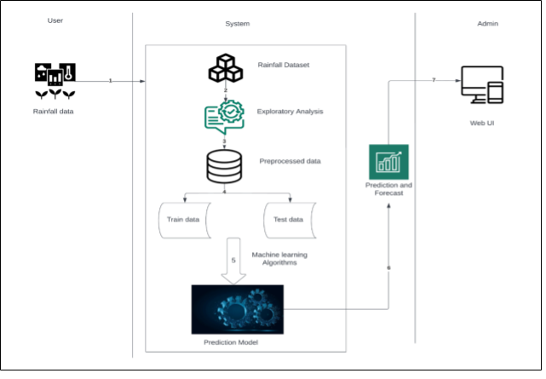

S.No | Characteristics | Description | Technology
1. | Open-Source Frameworks | Lightweight WSGI web framework for Python | PyJWT, Flask, IBM Cloud DB
2. | Security Implementations | Request authentication using JWT Tokens | HS-256, Encryptions, SSL Certs
3. | Scalable Architecture | Support for multi-dimensional feature processing | Render Cloud Hosting
4. | Availability | Web access maintained via cloud hosting | IBM Cloud Hosting
5. | Performance | Efficient inference time for real-time predictions | Gunicorn HTTP Server
Table-1 : Components & Technologies:
S.No | Component | Description | Technology
1. | User Interface | How user interacts with application e.g. Web UI, Mobile App, Chatbot etc. | HTML5, CSS3, Jinja2 Templates
2. | Application Logic-1 | Logic for a process in the application | Python (Flask)
3. | Application Logic-2 | Data Imputation and Feature Scaling | Scikit-learn (SimpleImputer, StandardScaler)
4. | Application Logic-3 | Core Machine Learning Intelligence | Random Forest / Logistic Regression (Pickle)
5. | Database | Serialized model and scaler storage | MySQL, NoSQL, Pickle (.pkl files) etc.
6. | Cloud Database | Public hosting and production environment | Render (Gunicorn)
Table-2: Application Characteristics:

